|  |  |
| --- | --- |
| **King Fahd University of Petroleum & Minerals**  **College of Computer Science & Engineering**  **Information & Computer Science department** |  |

**ICS 201 Project Report**

**Term 192**

**Team 25**

**Fruit Smash**

**Prepared for Dr.Garout & Dr.Alothman**

**Made by Mohammed Khalil & Osama Salem**

Brief description of the solution:

In the beginning, we tried to make a good game that can be showed to others not just for the project purpose.

So, we started by making some researches about what we can do and the best uses of javaFx in our game (see the references).

We used a class called AnimationTimer because it has a method that recurs in every frame of the object movement so the movement can be controlled smoothly.

Also, in all of the scenes in the game we used the AnchorPane because we can arrange the nodes in it with specific locations that we can keep it as it is even if we change the size of the pane.

For the clicking objects we used rectangles and circles instead of buttons because we can edit their Filling easier and we can give them the shapes that we like. And we did the same idea for the flying objects. We also added bringing new ideas like the bombs and how they can be defused using the secondary mouse button.

In the beginning of making the motion we first made the object move in a straight line (x-axis motion) to test our AnimationTimer code and make sure it works well.

After that we wrote some projectile motion equations from physics to make the object move in 2D (x-axis and y-axis)

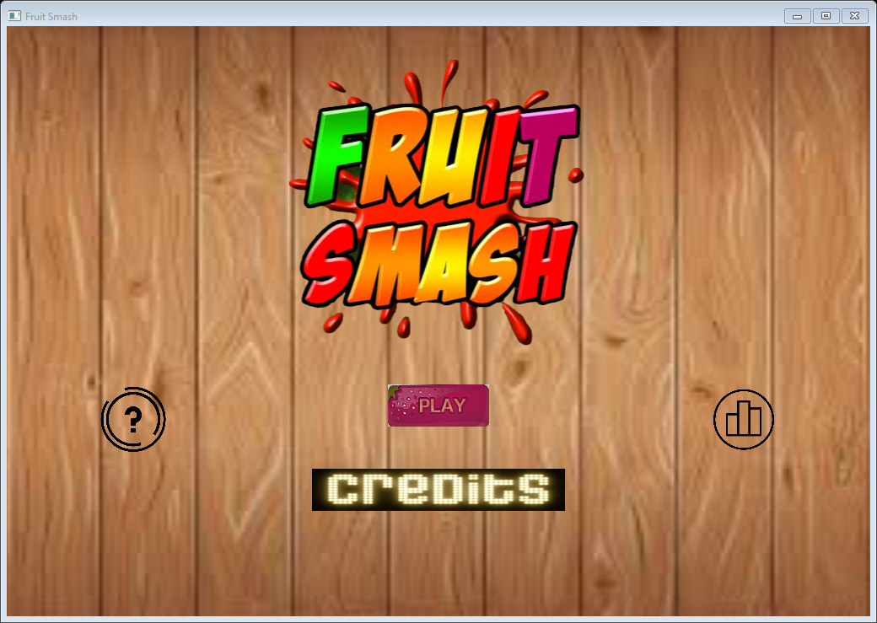And then we tried to work on the main menu, we added the leaderboard, help, and credits buttons.

The last thing we did was adding sounds to the game when clicking objects or when the game ends as well as the smashing effects.

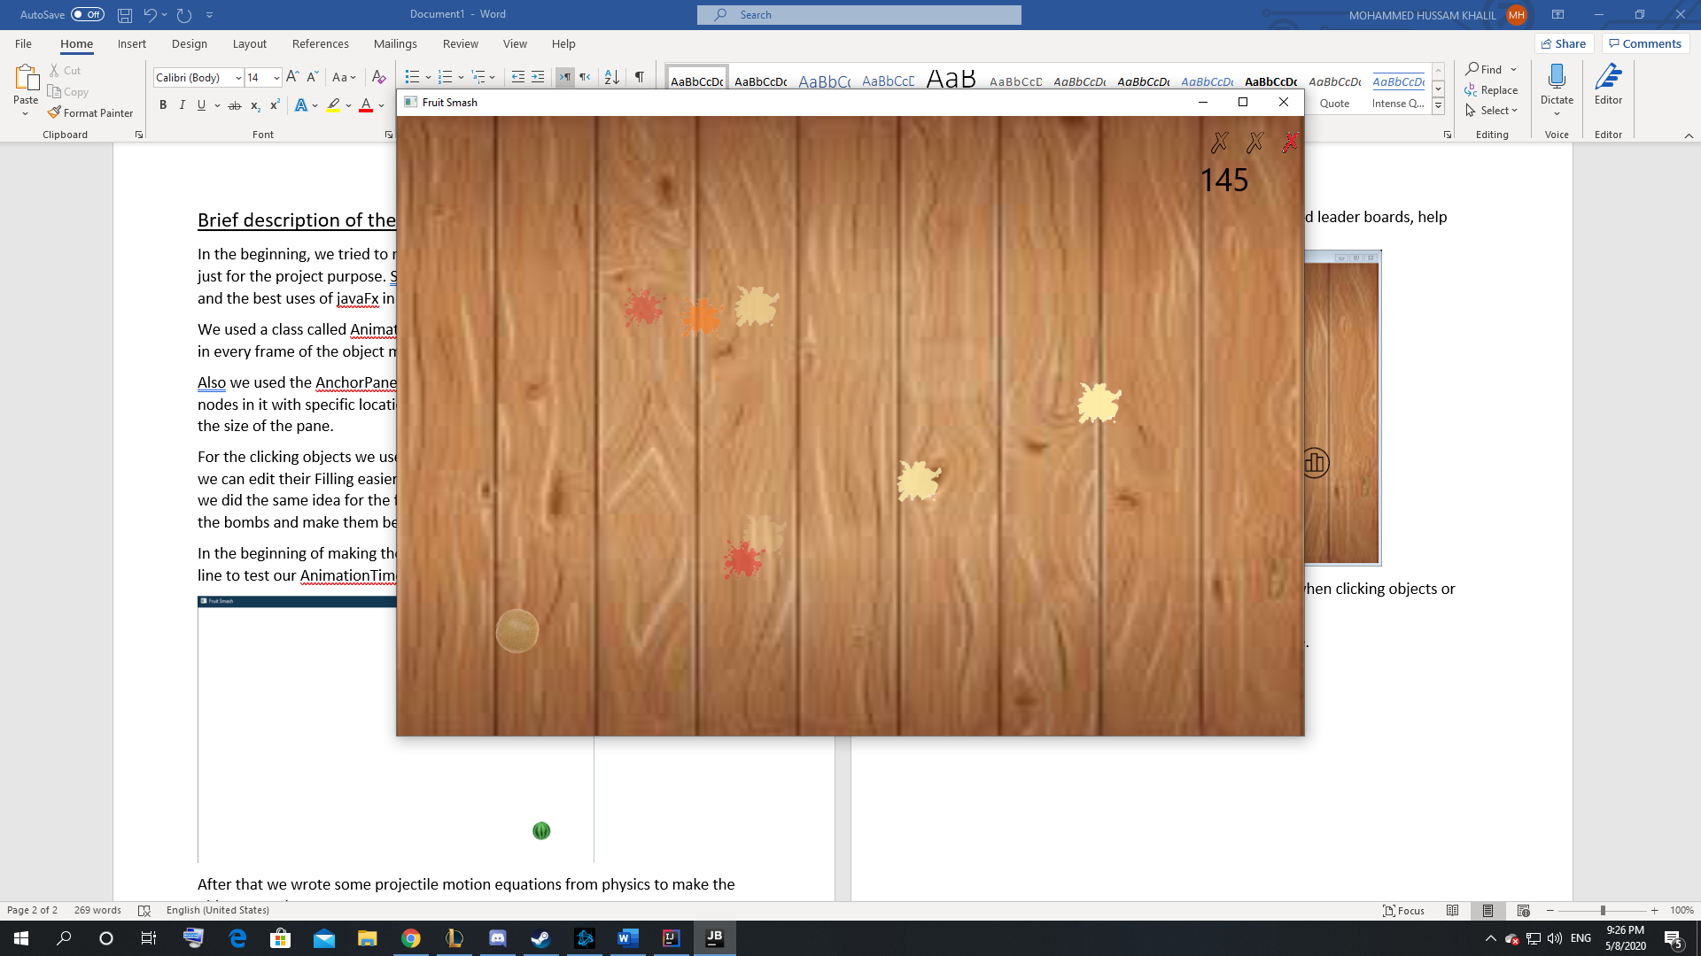And here are some pictures after we finished the game.

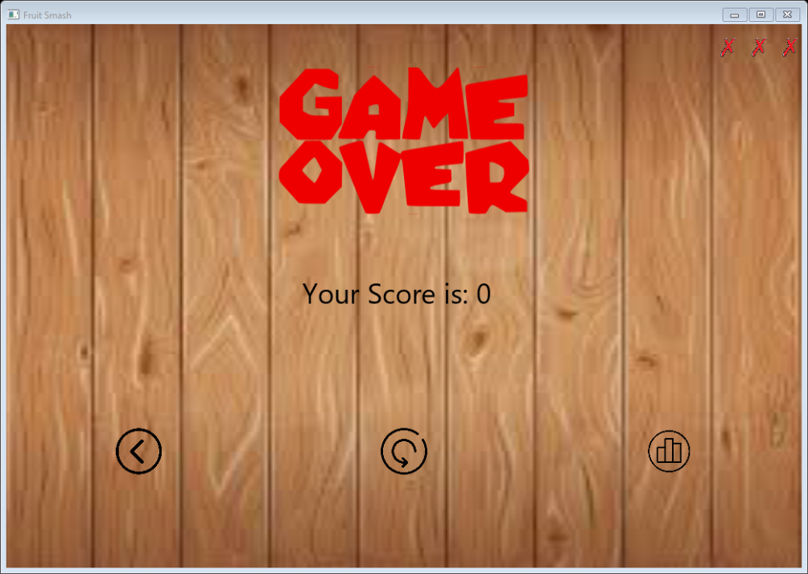

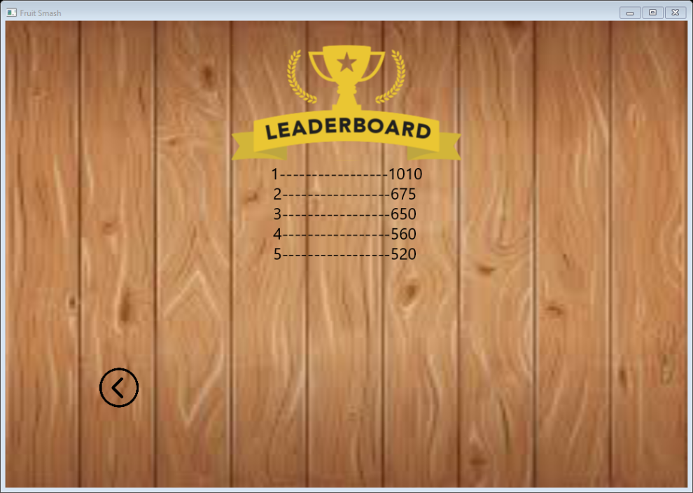

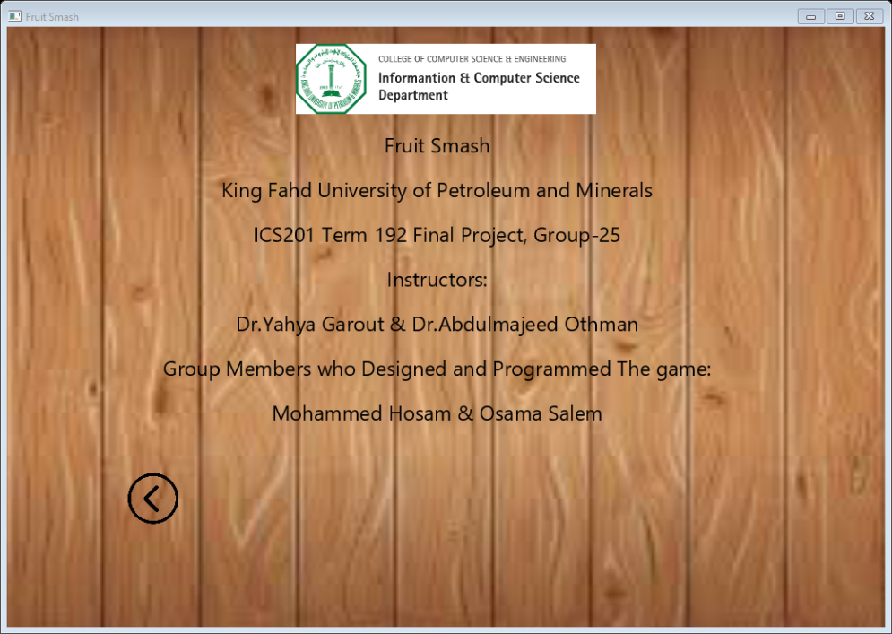

The distribution of the work among group members

We had a meeting every two days that lasts for an approximate time of 2 hours where we put a plan of what we want to achieve in the meeting then we distribute the work in half and if someone faced an issue the other will help him and we continued working in that way. And after the meeting everyone can try the game and give feedback.

we can say that all the work was made by the 2 of us together and that helped us explore the field of javaFx in a better way.

References

<https://gamedevelopment.tutsplus.com/tutorials/introduction-to-javafx-for-game-development--cms-23835>